1. 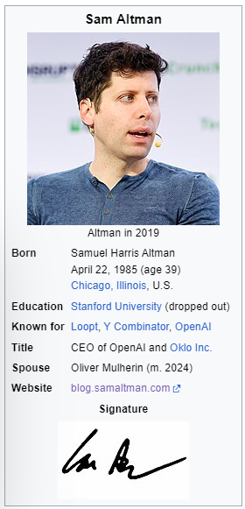**Individual (E.g. Sam Altman)**

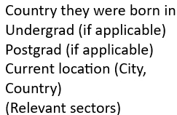<Short bio of where they are from, where they have worked and what they do now>

Information about the organizations they are affiliated with:

<Some text about the current organisations they work for>

<Link to personal website>

|  |
| --- |
| Relevant publications  A close up of a text  Description automatically generated  A close up of a text  Description automatically generated  Links to relevant co-workers / co-autors /competitors :  Dario Amodei  Satya Nadella  Ilya Sutskever |

**Extra potential features:**

|  |
| --- |
| Embed their last tweet (s) |

|  |
| --- |
| Beta: Their vision on AI (sourced from the internet) |

**Google Trends (Maybe only relevant for most influential people)?**

**2. Company Profile (E.g. Hugging Face)**



|  |
| --- |
| Bio about where the company is from, what it does and notable facts |

Relevant employees:

|  |
| --- |
| Clem Delangue  Merve Noyan  Moritz Laurer |

|  |
| --- |
| Offices (also in boxes with links): NYC, Paris |

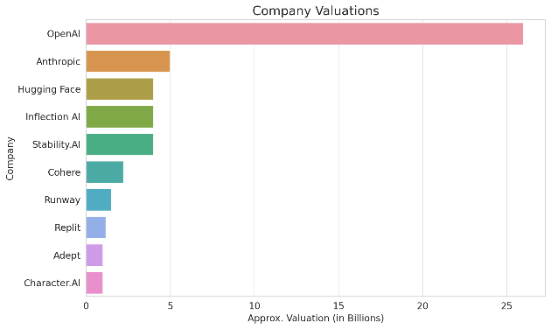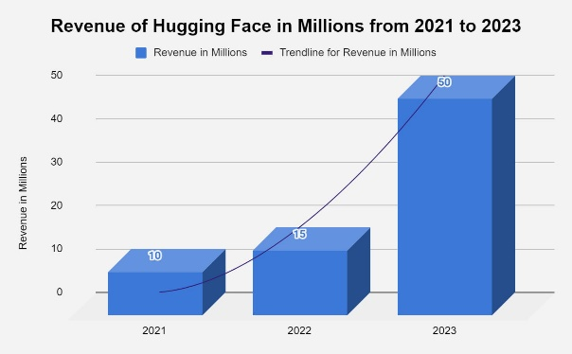<Text about viz of trajectory of company over time: Instead of revenue it could be investment / share value / etc. and some chart comparing the company to others:>

Extra, maybe not feasible:

|  |
| --- |
| Collaborations (ecosystem): Partnerships / software/hardware integrations. Potentially with a short description explaining the meaning of the partnership, e.g. for [Langchain](https://huggingface.co/blog/langchain): |

* langchain_huggingface, a partner package in LangChain jointly maintained by Hugging Face and LangChain.
* Host HF models on Azure or Google Cloud, etc.

|  |
| --- |
| Azure Sphere - WikipediaGoogle CloudLangChain in Chains #1: A Closer Look | by Okan Yenigün | Stackademic |